Dear Parents,
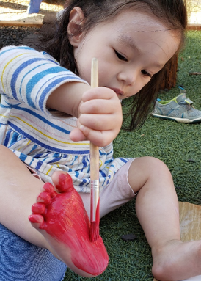
Welcome to the toddler classroom. You are receiving this letter as your infant is now transitioning to the toddler room. It’s an exciting time! With this transition there will be new friends, new experiences, new challenges, and a toddler flow for the day with social distancing and other safety precautions in mind. As your toddler transitions, whether they are coming from the infant room or home, they will have a new assigned primary caregiver in the toddler room. If your child is transitioning from infants, your new toddler primary caregiver will keep in contact with their infant primary caregiver throughout the process.
The toddler program allows the child to explore more in depth. Our philosophy is to give the child the freedom to explore their surroundings which can turn into a fun and messy learning experience. Here is an example of this messy-fun learning: there was a new child who would choose painting for the first two months. She would start each day by grabbing the brush and painting her hands. Two weeks later, she moved on to painting her arms. After focusing on her arms for a week, she moved on to painting her feet and legs. The next day she decided to paint her hands, arms, legs, and feet. As she continued exploring, she found new ways to paint. She would paint her hands different colors and then place them on a piece of paper. She continued to create art with her hands for the rest of the month. She then moved on to using a paint brush on a piece of paper. This child did more than just paint her body, it was a learning experience for her. As the famed educator, Bev Boss, said, “If it hasn’t been in the hand and the body, it can’t be in the brain”. This quote rings true with us and is practiced almost every day in the toddler classroom. When the children are given activities, they will either turn out as planned or turn into a learning experience for both the child and the teacher.
The toddler room also balances these changes and ideals with new health and safety concerns. We do this by allowing lots of space for our students to explore on their own, staggering drop-off/pick-up times, wearing face masks (or other protective barriers) when appropriate, and other protective measures for staff, students, and families. We are also continuing our school’s long-standing policies of frequent hand washing, switching out sanitized toys throughout the day, health checks, and other necessary cleaning and sanitation practices. The balance between safety and developmentally appropriate play is tricky these days, but we strive to walk that line successfully every day.
Our students are given independence while playing. T hey tend to have different perspectives from one another and we think that’s great. Our objective is to further enhance the knowledge of a child’s physical and social surroundings. For example, on rainy days, activities will be set up outside on the patio allowing the children the choice of getting wet or to stay dry, if desired. The children are able to hear the rain and the different sounds it creates. They are also able to reach out and touch the rain. They will, then, further explore by going outside to the yard when it stops raining. Some children will be drawn to the puddles and others won’t. Any of their surroundings can and do become a learning experience. We learn from the world around us and the world around us is messy. We embrace it and can’t wait to embrace it with your child! If you have any questions or concerns feel free to contact the toddler team.
Sincerely,
Toddler Staff

